**Topic: Formulae and Equations**

Time: 45 mins Marks: /45 marks

**No calculator allowed**



**Question One: [1, 2, 2, 2: 7 marks]**

Consider the following equation, $B=10A-3C$

a) Evaluate B, if A = 4 and C = 12

b) Evaluate C, if B = 40 and A = 1

c) Evaluate A, if B = 2 and C = 2

d) Evaluate A, if B=-2 and C=-2

**Question Two: [3, 3: 6 marks]**

a) Consider the following equation:

$$J=M(P+H)$$

i) Rearrange to make M the subject.

ii) Rearrange to make H the subject.

b) Consider the following equation: $\frac{1}{g}+\frac{2}{h}-\frac{3}{i}=12$

Rearrange to make *i* the subject. *Do not simplify your answer.*

**Question Three: [2, 2: 4 marks]**

A bike has wheels that are *d* cm in diameter.

a) Write an equation to represent how far the bike would travel in 30 full wheel turns.

b) Write an equation to represent how many wheel turns it would take to travel 3000 km.

**Question Four: [2, 3: 5 marks]**

A horticulturalist suggests that seedling growth would benefit from a particular vitamin which is usually used on the adult plant. The dose (*d* units) that should be given to a seedling, of *h* centimeters in height, can be calculated from the dose (*T* units) that would be given to the adult plant, using the rule: .

a) If the dose for an adult plant is 11 units, what would the dose be for a 4 cm seedling?

b) The rule is valid for *h* up to a certain value. Determine the upper limit for *h* and explain your reasoning.

**Question Five: [2, 3: 5 marks]**

Consider the following box with a length and width of 10 cm.

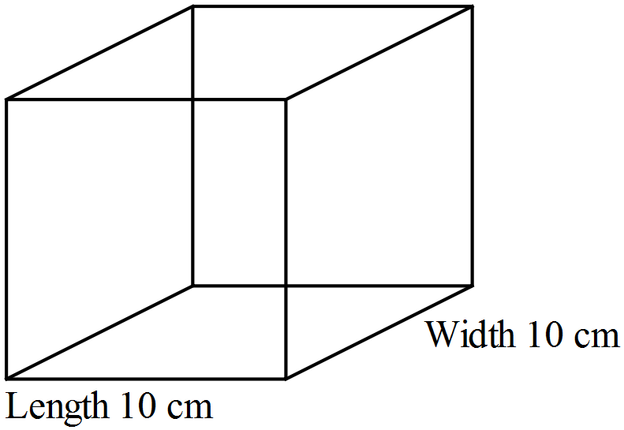

a) Write a formula to represent the total surface area of the box for height *h* cm.

b) If it is known that exactly $420{ cm}^{2}$ of paper is required to cover the surface of this box, calculate the height of the box.

**Question Six: [2, 1, 1: 4 marks]**

The following table is used to calculate the monthly balance on an account. The interest rate is 3.4% per month and a constant $150 is withdrawn each month.

|  |  |  |  |  |  |
| --- | --- | --- | --- | --- | --- |
|  | **A** | **B** | **C** | **D** | **E** |
| **1** | Month | Balance | Interest | Withdrawal | End Balance |
| **2** | 1 | 2000 | 68 | 150 | 1918 |
| **3** | 2 | 1918 | 65.21 | 150 | 1833.21 |
| **4** | 3 | 1833.21 |  |  |  |
| **5** | 4 |  |  |  |  |

a) Write the formula used to calculate the value in C4.

b) Write the formula used to calculate the value in E4.

c) Write the formula required for B5.

**Question Seven: [3 marks]**

A factory makes wedding dresses and suits. It takes 6 hours to cut the fabric for each wedding dress and 4 hours to cut the fabric for each suit. Each wedding dress requires 15 hours of sewing and each suit take 9 hours of sewing. To make a particular number of wedding dresses and suits it takes 40 hours a day to cut and 90 hours to sew. Write two equations to represent this information.

**Question Eight: [3 marks]**

Amos is growing vegetables and herbs in old wine barrels. The smaller wine barrel has a radius of *r* cm. The larger wine barrel has twice the radius of the smaller wine barrel.

Write an equation in terms of *r* for the total area of Amos’ vegetable and herb garden. Simplify your answer.

**Question Nine: [2, 4, 2: 8 marks]**

Consider the following equation, $p=6×\sqrt{q-9}+k$

a) Evaluate *p,* if q = 18 and *k* = 25

b) Evaluate *q*, if p = 20 and *k* = 8

c) For which values of *q* is this equation not valid?

**Formulae and Equations SOLUTIONS**

Time: 45 mins Marks: /45 marks

**No calculator allowed**



**Question One: [1, 2, 2, 2: 7 marks]**

Consider the following equation, $B=10A-3C$

a) Evaluate B, if A = 4 and C = 12

B = 40 – 36

 = 4

b) Evaluate C, if B = 40 and A = 1

40 = 10 – 3C

 30 = -3C

-10 = C

c) Evaluate A, if B = 2 and C = 2

 2 = 10A – 6

8 = 10A

 A = 0.8

d) Evaluate A, if B = -2 and C = -2

 -2 = 10A + 6

 -8 = 10A

A = -0.8

**Question Two: [3, 3: 6 marks]**

a) Consider the following equation:

$$J=M(P+H)$$

i) Rearrange to make M the subject.



$M=\frac{J}{P+H}$

ii) Rearrange to make H the subject.





$\frac{J}{M}=P+H$

$H=\frac{J}{M}-P$

b) Consider the following equation: $\frac{1}{g}+\frac{2}{h}-\frac{3}{i}=12$

Rearrange to make *i* the subject.







$hi+2gi-3gh=12ghi$

$hi+2gi-12ghi=3gh$

$i\left(h+2g-12gh\right)=3gh$

$i=\frac{3gh}{h+2g-12gh}$

**Question Three: [2, 2: 4 marks]**

A bike has wheels that are *d* cm in diameter.

a) Write an equation to represent how far the bike would travel in 30 full wheel turns.



b) Write an equation to represent how many wheel turns it would take to travel 3000 km.





**Question Four: [2, 3: 5 marks]**

A horticulturalist suggests that seedling growth would benefit from a particular vitamin which is usually used on the adult plant. The dose (*d* units) that should be given to a seedling, of *h* centimeters in height, can be calculated from the dose (*T* units) that would be given to the adult plant, using the rule: .

a) If the dose for an adult plant is 11 units, what would the dose be for a 4 cm seedling?





$d=11×\frac{1+4}{10}$

$d=5.5 units$

b) The rule is valid for *h* up to a certain value. Determine the upper limit for *h* and explain your reasoning.

$$h<9$$

You are then multiplying the adult does by 1 which means the seedling is now an adult plant.

**Question Five: [2, 3: 5 marks]**

Consider the following box with a length and width of 10 cm.



a) Write a formula to represent the total surface area of the box for height *h* cm.

 SA = 200 + 20*h* + 20*h*

 SA = 200 + 40*h*

b) If it is known that exactly $420 {cm}^{2}$ of paper is required to cover the surface of this box, calculate the height of the box.



420 = 200 + 40*h*

220 = 40*h*



$\frac{22}{4}=h$

$$h=5.5 cm$$

**Question Six: [2, 1, 1: 4 marks]**

The following table is used to calculate the monthly balance on an account. The interest rate is 3.4% per month and a constant $150 is withdrawn each month.

|  |  |  |  |  |  |
| --- | --- | --- | --- | --- | --- |
|  | **A** | **B** | **C** | **D** | **E** |
| **1** | Month | Balance | Interest | Withdrawal | End Balance |
| **2** | 1 | 2000 | 68 | 150 | 1918 |
| **3** | 2 | 1918 | 65.21 | 150 | 1833.21 |
| **4** | 3 | 1833.21 |  |  |  |
| **5** | 4 |  |  |  |  |

a) Write the formula used to calculate the value in C4.





$C4 = B4 * \frac{3.4}{100}$

b) Write the formula used to calculate the value in E4.

 E4 = B4 + C4 – D4

c) Write the formula required for B5.

 B5 = E4

**Question Seven: [3 marks]**

A factory makes wedding dresses and suits. It takes 6 hours to cut the fabric for each wedding dress and 4 hours to cut the fabric for each suit. Each wedding dress requires 15 hours of sewing and each suit take 9 hours of sewing. To make a particular number of wedding dresses and suits it takes 40 hours a day to cut and 90 hours to sew. Write two equations to represent this information.

Let w = number of wedding dresses

Let s = number of suits

6w + 4s = 40

15w + 9s = 90

**Question Eight: [3 marks]**

Amos is growing vegetables and herbs in old wine barrels. The smaller wine barrel has a radius of *r* cm. The larger wine barrel has twice the radius of the smaller wine barrel.

Write an equation in terms of *r* for the total area of Amos’ veggie and herb garden. Simplify your answer.





$A=πr^{2}+π{\left(2r\right)}^{2}$

$=πr^{2}+4πr^{2}$

$=5πr^{2}$

**Question Nine: [2, 4, 2: 8 marks]**

Consider the following equation, $p=6×\sqrt{q-9}+k$

a) Evaluate *p,* if q = 18 and *k* = 25





b) Evaluate *q*, if p = 20 and *k* = 8









c) For which values of *q* is this equation not valid?

